Katie Gallagher
KNH 413
Professor Matuszak
10 February 2015

Case Study 1: Peptic Ulcer Disease

- List all food items that may contribute to GG’s condition and explain why.
  - Foods that may contribute to peptic ulcer disease include black and red pepper, caffeine, coffee, and alcohol. Her regular intake of frozen dinners, fried foods, fast foods, chocolate, coffee, and alcohol would have each contributed to her condition because the high fat, sodium, and cholesterol content of these foods can increase acid secretion or cause direct irritation to gastric mucosa. (Nelms, 2011, pg. 363).

- List any additional oral intakes that may have contributed to GG’s condition and explain why.
  - Other oral intakes that may have contributed to GG’s condition include cigarettes because they contain chemical irritants that cause damage to the stomach and increase risk of peptic ulcers and aspirin because salicylates are linked to increased gastric irritation, and antacids. (Nelms, 2011, pg. 362-363).

- List the non-oral stimulants that could contribute to GG’s condition and what she could do to change them.
  - The non-oral stimulants that could contribute to GG’s condition would be her stress levels, lack of sleep, and physical inactivity. Though stress is no longer linked to be a cause of peptic ulcers, many individuals suffering from peptic ulcers report that emotional stress increases peptic ulcer pain. Sleep apnea has been proven to contribute to initiation or progression of peptic ulcers. Finally, increasing physical activity has been shown to reduce the incidence of duodenal ulcers. Therefore, her physical inactivity may be a large contributor of her condition. (Johns Hopkins, 2014), (NCBI, 2014).

- List the symptoms of GG’s gastritis.
  - GG’s symptoms are consistent with the gastritis diagnosis. She has had severe stomach pain radiating from the right side up to the chest, increased pain and burning after consuming a meal, loss of appetite, burning sensation in the RLQ, and regular severe stomach pain,

- Was a bland diet necessary? Explain and list the principles of the diet plan you think GG should follow.
  - Recent research has shown that a bland diet is ineffective in the treatment of peptic ulcers though GG should limit her intake of caffeine, alcohol, spicy foods, and fatty or fried foods that includes fast foods and convenience foods. These foods have been proven to increase gastric acids and may irritate patients with gastritis. GG’s diet plan should be constructed to increase her consumption of fruits and vegetables, low fat dairy, baked or grilled meats, with tolerated fats. She should also pay careful attention to her meal timing. GG should consume smaller, more frequent meals while avoiding lying down after eating or eating before bedtime. (Nelms, 2011, pg. 363), (Johns Hopkins, 2014).

- What is the mechanism of action of the medications GG is receiving? Carafate, AlternaGel, and Pepcid?
Medication | Mechanism
Carafate | Carafate is made up of sucralfate which binds to duodenal and gastric ulcers due to its viscous adhesiveness and the bridges formed between negative sucralfate and positively charged proteins in mucosal lesions in order to help protect against acid and aid in healing. (NCBI, 2014).
AlternaGel | AlternaGel is composed of aluminum hydroxide and binds to the phosphate ions in the intestine to form insoluble aluminum phosphate, which prevents calcium stones. It is an antacid that lowers the existing acid in the stomach. (Medicine Plus, 2014).
Pepcid | Pepcid is composed of famotidine and works to bind to H₂-receptor to block histamine effects resulting in reduced gastric acid secretions and a reduced gastric volume. (DrugBank, 2013).

- List the nutrient-drug interactions that are associated with these medications.
Medication | Nutrient-Drug Interactions
Carafate | Should be taken on an empty stomach at least 1-2 hours before consuming a meal. Other drugs should not be taken one half hour before or after.
AlternaGel | Has shown to interfere with calcium metabolism and thiamin absorption thus should not be taken at mealtime.
Pepcid | Take 15-60 minutes before consuming food. Can reduce the absorption of vitamin B1₁₂, zinc, or iron and it is vitamin C and E supplementation is recommended to protect the lining of the stomach.
(Medicine Plus, 2014).

- What are GG’s IBW and %IBW?
  - IBW: 5’2” = 100 + 2(5) = 110 lbs.
  - % IBW = 98 lbs./110 lbs. = 89%

- Estimate her daily energy needs using the Harris-Benedict equation and appropriate stress factor.
  - REE for females: 655.1 + 9.6W + 1.9H – 4.7A
  - REE = 655.1 + 9.6(44.54 kg)+ 1.9(157.48 cm) – 4.7(27 yrs.)
  - REE = 655.1 + 427.6 + 299.2 – 126.9
  - REE = 1255 x 1.3 = 1631.5 kcal/day
  - Total Energy Requirements: 1600 – 1700 kcal/day
  - Stress factor of 1.3 due to mild to moderate physical activity as well as metabolic stress from the ulcer.

- What might be the cause of the LUQ along with her usual pain?
  - LUQ pain is often attributed to stomach ulcers. Abnormal ALP lab values may also contribute to this pain because liver cirrhosis is another common cause of left upper quadrant pain. Her excessive alcohol consumption, smoking, and stress may have damaged the liver and exacerbated her pain.
(MD-Health.com, 2015).

- In the second set of lab values, glu, BUN, cr, ser alb, Na, K, Cl, hgb, and hct all dropped. This probably means that GG was:
  - Bleeding
  - Eating poorly in the hospital
  - Dehydrated when the first labs were drawn
  - Over hydrated when the second labs were drawn
All of the listed laboratory values appear to drop with overhydration.
(Benock & Riley, 2015).

- In the second set of lab values, serum amylase, AST, and ALT all dropped. This probably means that:
  - Enzymes were elevated due to alcohol
  - Her medications caused them to drop
  - GG was dehydrated with the first labs were drawn
  - GG was over hydrated when the second set of labs were drawn
The analyzed lab values are indicative of liver impairment which can be attributed to her alcohol consumption.

- Refer to the two lab tables again, and note that two days after admission, GG’s Alk Phos and CPK remained essentially unchanged. Why?
- These enzymes are not affected by alcohol or hydration
- Her medications caused them to drop
- Dehydrated when the first labs were drawn
- Over hydrated when the second set of labs was drawn
Her hydration status and alcohol consumption do not impact the alk phos and cpk values.

- What diagnostic test(s) indicate(s) that GG has an ulcer?
  - Diagnostic tests that indicate that GG has an ulcer are the esophagogastroduodenoscopy, stool tests that revealed blood in her stool, and the detection of H.pylori.

- Briefly sketch the anatomical position where GG’s ulcer can be found?

- Define:
  - H₂ Antagonist – An agent used to block the action of histamine on parietal cells in the stomach, decreasing the production of acid by these cells.
  - Proton Pump Inhibitor – any of a group of drugs that inhibit the activity of proton pumps and are used to inhibit gastric acid secretion in the treatment of ulcers.
(NCBI, 2014).

- What is the mechanism of action of the following medications GG is receiving: Nexium, amoxicillin, and clarithromycin?
Medication | Mechanism
Nexium | A proton pump inhibitor that reduces gastric acid by blocking the final step in acid production.
Amoxicillan | Penicillin that blocks the multiplication of bacteria by preventing the formation of cell walls.
Clarithromycin | A type of drug that interferes with the protein synthesis of bacteria.
(Medicine Plus, 2014).

- GG was not receiving counsel at the time the major bleeding started. If you had the opportunity to counsel GG just before the bleeding, in what areas would you feel competent to counsel her and in what areas would you refer her to someone else? Investigate the agencies in your area that are available to provide assistance to someone like GG.
  - I would feel competent to counsel her in the areas of diet and exercise. I would refer her to someone else for the areas of stress management, smoking cessation, and maybe an agency for her alcohol consumption. Agencies that would provide these services might be Critical Incident Stress Management Services (CISM), Smoking.gov to find local smoking cessation programs, and alcoholics anonymous to help with the excessive alcohol consumption.

- What is the significance of dark stools?
  - Dark stool is an indicator of peptic ulcers because dark or black stool indicates that there is bleeding in the upper part of the GI tract.
(Medicine Plus, 2014).

- Give the pathophysiology of the following abnormal lab values: BUN, NH₃, and WBC.
BUN | A high BUN level may indicate kidney damage or internal bleeding.
NH₃ | A high NH₃ may indicate liver damage or GI bleeding.
WBC | A high white blood cell count indicates an inflammatory response.
(Nelms, 2011).

- GG was probably dehydrated on admission since she had been drinking. This means that some of her lab values were probably higher/lower than indicated.

- After admission GG received packed cells and IV fluids. How would that affect the next set of lab values?
GG’s next set of lab values would be lower than normal with overhydration because there is a lower concentration of electrolytes and other blood laboratory values upon hydration.
(Benock & Riley, 2015).

- Define the following terms:
  - Packed cells- A preparation of blood cells separated from plasma to restore adequate levels of hemoglobin and RBCs without overloading the vascular system with excess fluid.
  - Abdominal tap- belly tap, helps differentiate a surgical abdomen.
  - Perforated ulcer- an ulcer extending through the wall of an organ.
  - Fistula- an abnormal opening or passage between two internal organs or from an internal organ to the surface of the body.
  - Exploratory Laparotomy- an operation into the peritoneal cavity where the surgeon examines all surface lesions.
  - Billroth I- excision of the pylorus with an end to end of the s and the duodenum, it helps manage peptic ulcer disease.
  - Vagotomy- severing of the vagus nerve from gastric surgery.

- Sketch a Billroth I:
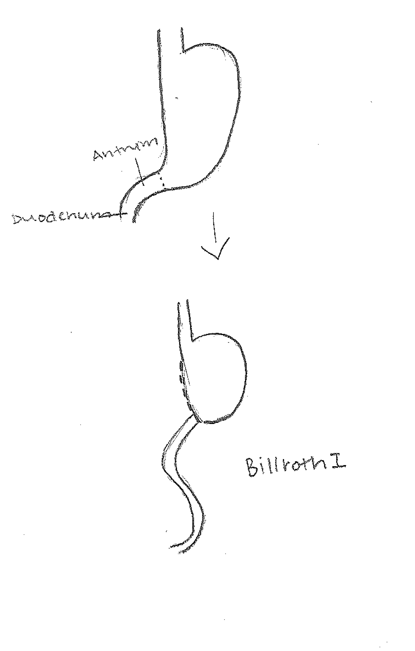

- Compare a Billroth I to a Billroth II as to anatomical changes as well as to dietary changes, if any.
  - Billroth I is when the top half of the stomach is reconnected to the duodenum. Billroth II is when the top half of the stomach is reconnected to the small bowel rather than the duodenum and the end of the duodenum is sewn up. Both remove part of the stomach. Dietary changes are similar for the two procedures but both must watch for gastric dumping syndrome, malabsorption, and reduced stomach capacity. (Nelms, 2011, pg. 364-365).

- Calculate GG’s energy and protein needs.
  - REE for females: 655.1 + 9.6W + 1.9H – 4.7A
  - REE = 655.1 + 9.6(44.54 kg)+ 1.9(157.48 cm) – 4.7(27 yrs.)
  - REE = 655.1 + 427.6 + 299.2 – 126.9
  - REE = 1255 x 1.5 = 1882.5 kcal/day
  - Stress Factor of 1.5 because she is healing from surgery
  - Total Energy Requirements: 1800-1900 kcal/day.

- Estimated Protein Needs:
- 1.2-1.5 g/kg for wound healing
- 44.54kg x 1.2g = 53.5g
- 44.54kg x 1.5g = 66.81g
- 54 – 67 g of protein/day

- List the principles of a postgastrectomy diet and briefly describe the scientific basis for each principle.
  - Postgastrectomy, adequate energy and protein intake to ensure appropriate healing must be prescribed. Recommend appropriate nutrition support if progression to solid food does not proceed successfully.
  - Initiate slow progression of solid food to prevent onset of early and late dumping syndromes. Initially avoid all simple sugars and the first meal should consist of protein, fat and complex carbohydrate but with only one to two food items.
  - Patients may be initially lactose intolerant and dairy products should be avoided.
  - Slow progress to five to six small meals each day.
  - Consume liquids 30 minutes to 1 hour after solid food.
  - Lie down after eating.
  - Consider additional functional fibers to delay gastric emptying and assist with treatment of diarrhea.
  - Prevent development of nutrient deficiencies.
  - Liquid multivitamin and mineral supplements should be initiated.
  - Vitamin B₁₂ injections if warranted.
  - Monitor other serum levels and supplement as necessary.
  - Provide nutrition education that will promote optimal nutrition. (Nelms, 2011, pg. 366).

- Is it possible that GG’s diet will ever change or do you believe she will be on a postgastrectomy diet for the rest of her life? Explain your answer.
  - I do not believe that GG’s diet will ever change. Due to her surgery, it is vital to keep a postgastrectomy diet for the rest of her life to ensure that she keeps herself healthy. One day she may be able to accommodate some different foods in her diet once she heals a bit more, but she will need to observe this diet as best she can so that she does not create more damage.

29. If GG were hospitalized for an extended period of time and required a tube feeding via duodenum or jejunum, what characteristics would be appropriate for the tube feeding you would use?
Characteristics that would be important to use would be small frequent feedings, high protein, low carbohydrate, liquid between meals, and calorie dense in order to ensure adequate energy. It is important to consider which type of tube feed to use because not all would be appropriate due to her surgery.

30. Compare several of the enteral supplements that would be appropriate for GG.
Product | Producer | Form | Cal/mL | Non-pro cal/g N | Pro (g/L) | CHO (g/L) | Fat  (g/L) | Na mg | K  mg | mOsm /kg water | Vol to meet RDA in ml | g of fiber /L | Free H2O /L in ml
Ensure high protein | Ensure | vanilla ready to drink | 0.97 | 93:1 | 12 | 31 | 6 | 290 | 500 | 610 | 237 | 0
Ensure plus | Ensure | Butter pecan ready to drink | 1.5 | 146:1 | 13 | 50 | 11 | 220 | 400 | 680 | 237 | 0
Ensure Enlive | Ensure | Apple ready to drink | 1.01 |  | 7 | 43 | 0 | 35 | 35 | 796 | 198 | 0

References

Benock, J., Riley. (2015). Fluid Excess/Intoxication. Retrieved February 9, 2015 from http://www.physiopedia.com/Fluid_Excess/Intoxication#Diagnostic_Tests.2FLab_Tests.2FLab_Values

DrugBank: Famotidine (DB00927). (2013). Retrieved February 9, 2015, from http://www.drugbank.ca/drugs/DB00927

Johns Hopkins. (2014). Stomach and Duodenal Ulcers. Retrieved February 9, 2015, from http://www.hopkinsmedicine.org/healthlibrary/conditions/digestive_disorders/stomach_and_duodenal_ulcers_peptic_ulcers_85,P00394/

MD-Health.com. (2015). Upper Left Abdominal Pain. Retrieved February 9, 2015, from http://www.md-health.com/Upper-Left-Abdominal-Pain.html

Medicine Plus. (2014). Retrieved from http://www.nlm.nih.gov/medlineplus/druginfo/meds/a681049.html

National Center for Biotechnology Information. (2014). Retrieved February 9, 2015, from http://www.ncbi.nlm.nih.gov/pubmed/23410566

Nelms, M. (2011). Nutrition Therapy and Pathophysiology (2nd ed.). Belmont, CA: Wadsworth, Cengage Learning.

